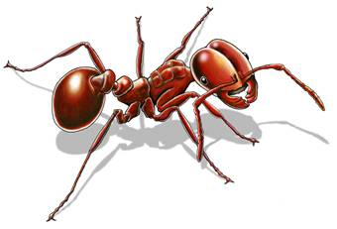
Insects

Fill in the sheet answering the following:

What can insects do, what do insects have, and what are insects?

CAN | HAVE | ARE

